Title Page
RECOMID: A Spotify-Based Music Recommendation and Playlist Construction System
Music Recommender - Personalized Suggestions Powered by Spotify
Prepared by: Bryce Olboc, Ralph Acorda
Course: BSCS AGD 3rd
Instructor: Dean Clarissa Vicente
Institution: Baliuag University
Date: March 2026
Abstract
RECOMID is a full-stack web-based music recommendation system that integrates Spotify authentication, personalized recommendation retrieval, and playlist construction into one user workflow. The project addresses a common practical gap in recommendation systems: users can receive recommended songs, but conversion into a final playlist is often fragmented or error prone. To solve this, RECOMID combines a browser-based interface, Flask backend services, Spotify Web API integration, and local SQLite persistence for secure token lifecycle handling. The system supports top-track analysis, recommendation generation, track validation for market and availability constraints, and robust playlist creation with batching and partial-success handling when some songs are blocked by Spotify. In addition, it provides user-facing transparency through popup summaries and blocked-song details, including direct Spotify links for manual follow-up. This paper presents the project in TIOC format and explains the purpose of five technologies used in the implementation: HTML, CSS, JavaScript, Python, and SQL. The findings show that multi-language integration enables a reliable, user-centered recommendation-to-playlist pipeline in a real API-constrained environment.
Keywords: music recommendation, Spotify API, Flask, OAuth, playlist automation, full-stack web system, SQLite
1. T - Title
RECOMID: A Spotify-Based Music Recommendation and Playlist Construction System
2. I - Introduction
Music platforms generate large content catalogs, making personalized discovery essential for user engagement. However, recommendation interfaces alone are insufficient when users must manually repeat steps to build playlists. RECOMID is designed to close this workflow gap by allowing users to authenticate via Spotify, retrieve recommendation candidates based on listening behavior, and add selected songs directly into a Spotify playlist.
The project also addresses real-world constraints that affect production-like systems, such as blocked tracks, account market differences, OAuth token expiration, and API rate limits. Instead of failing fully when constraints are encountered, the system emphasizes resilient behavior and transparent user feedback.
3. O - Objectives
- Implement secure Spotify OAuth login and token lifecycle management.
- Retrieve user-contextual track data and generate personalized recommendations.
- Enable end-to-end playlist creation directly from selected recommendation results.
- Add robust handling for blocked tracks and partial-add outcomes.
- Integrate five programming languages into one coherent full-stack architecture.
4. C - Content
4.1 System Overview
RECOMID follows a client-server architecture:
- The browser renders the user interface and captures interactions.
- JavaScript sends asynchronous requests to backend endpoints.
- Flask handles business logic and external API orchestration.
- Spotify Web API provides profile, track, recommendation, and playlist operations.
- SQLite persists user token and session-related data.
4.2 Architecture Diagram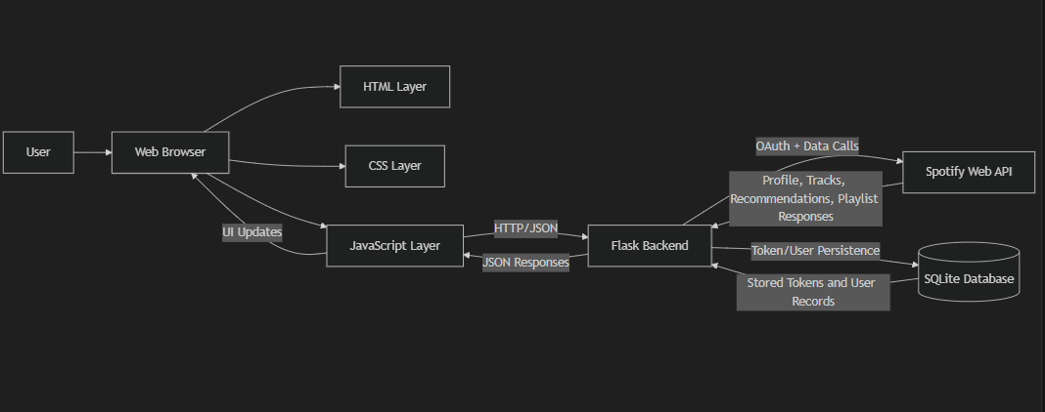
4.3 Process Flow Diagram
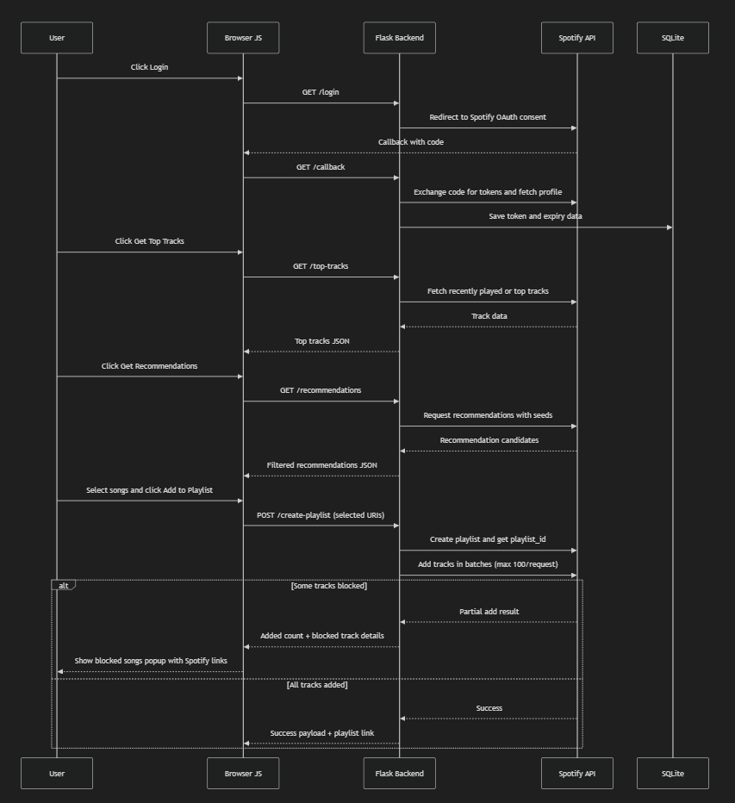

4.4 Purpose of the Five Programming Languages
Language | Purpose in RECOMID | Contribution to System Operation
HTML | Structural layout of pages and components | Defines controls, sections, cards, modals, and popup containers
CSS | Visual styling and responsive behavior | Controls branding, readability, spacing, cards, and popup design
JavaScript | Client logic and interaction control | Fetches backend APIs, manages UI state, handles selections and popup rendering
Python | Backend processing and API orchestration | Implements authentication, recommendation logic, filtering, playlist creation, and retry handling
SQL | Data persistence and relational storage | Stores users, access tokens, refresh tokens, and token expiry metadata
4.5 How These Languages Work as One Integrated System
The system functions as an execution chain rather than isolated parts. HTML defines the interface contract. CSS applies visual semantics and responsive layout. JavaScript binds user actions to asynchronous API calls. Python receives these calls, applies business rules, and communicates with Spotify. SQL ensures continuity by persisting token and user records needed for authenticated requests over time. Returned JSON is then transformed by JavaScript into updated UI components. This creates a closed loop: user action, backend orchestration, external API response, and immediate interface feedback.
4.6 Key Technical Features
- OAuth-based login with required Spotify scopes for profile, listening history, and playlist modification.
- Recommendation generation with fallback paths and market-aware filtering.
- URI normalization into spotify:track:TRACK_ID format before playlist insertion.
- Batch add operations (maximum 100 URIs per request) to follow Spotify constraints.
- Partial-success design: non-blocked tracks are still added even if some fail.
- Blocked-song transparency with detailed popup entries and direct Spotify links.
- Retry-after-aware handling for rate-limited POST operations.
4.7 Reliability and Error Handling
The implementation uses defensive mechanisms for unstable network and API scenarios:
- Token refresh with expiry checks.
- Retry strategy for transient API failures and 429 responses.
- Graceful degradation in recommendation and playlist operations.
- Explicit user feedback for blocked tracks, rate limits, and partial completion.
4.8 Limitations and Future Enhancements
- Recommendation quality depends on Spotify endpoint behavior and available user listening data.
- Regional licensing can still prevent exact track additions even with robust fallback logic.
- Future work may include offline analytics logging, A/B ranking strategies, and a recommendation explainability panel.
5. Conclusion
RECOMID demonstrates a practical full-stack architecture for recommendation-to-action continuity in music systems. By integrating HTML, CSS, JavaScript, Python, and SQL around Spotify APIs, it achieves a complete pipeline from user authentication to playlist creation. Its main strength lies in resilient behavior under real-world constraints, especially blocked tracks and API limits, while maintaining user transparency and control. As a result, RECOMID serves as a strong academic and applied example of integrated web system design for personalized content workflows.
References
- Spotify for Developers. Web API Reference. https://developer.spotify.com/documentation/web-api
- Spotify for Developers. Authorization Guide. https://developer.spotify.com/documentation/web-api/tutorials
- Pallets Projects. Flask Documentation. https://flask.palletsprojects.com
- Spotipy Documentation. https://spotipy.readthedocs.io
- SQLite Documentation. https://www.sqlite.org/docs.html
- Mozilla Developer Network. JavaScript, HTML, and CSS Web Docs. https://developer.mozilla.org

